PROJECT PROGRESS REPORT
(Progress Report no. 2)
1. Student Information
Student Name | PATEL MAN VISHNUBHAI.
Enrollment Number | 25IC03CA053
Program/Branch | Master Of Computer Applications
Semester | 3
Contact Number | 8849948963
Email ID | 25ic03ca053@ppsu.ac.in

2. Project Details
Type | Research Project
Department/Domain | MCA CA(DS/ML) / AI & ML
Mentor Name | Srikant Singh
Start Date | 08-06-2026
End Date | 03-10-2026

3. Work Progress Summary
- Project Title:
- OpenCV - Based System for Crack Identification and Width Estimation

- Requirement analysis:
The proposed system aims to automatically detect surface cracks and estimate their width using OpenCV image processing techniques. Traditional crack inspection is performed manually, which is time-consuming, subjective, and prone to human error.
The system should be capable of processing images captured from cameras or drones, identifying crack regions accurately, and estimating crack width in real time. It should provide reliable results with minimal human intervention and support different lighting conditions and crack patterns. The system should also generate visual outputs highlighting detected cracks along with their measured width for further analysis.
- Feasibility study:
Technical Feasibility
- The project is technically feasible because it uses open-source technologies such as Python and OpenCV.
- Standard computers with moderate processing power are sufficient to execute image processing algorithms.
Economic Feasibility
- The project has a low implementation cost since all required software tools are freely available.
- No expensive hardware or commercial software licenses are required.
Operational Feasibility
- The system is easy to operate and can assist engineers and inspectors in performing faster and more accurate crack analysis.
- It reduces manual effort and improves inspection efficiency.
Schedule Feasibility
- The project can be completed within the allotted academic timeline by following phases such as literature review, system design, implementation, testing, evaluation, and documentation.

- Technology Selection:
Component | Technology
Programming Language | Python
Image Processing | OpenCV
Numerical Computing | NumPy
Data Visualization | Matplotlib
Image Handling | Pillow
Development Environment | Visual Studio Code
Database Store Data | MongoDB
Operating System | Windows 10/11

- Proposed Methodology:

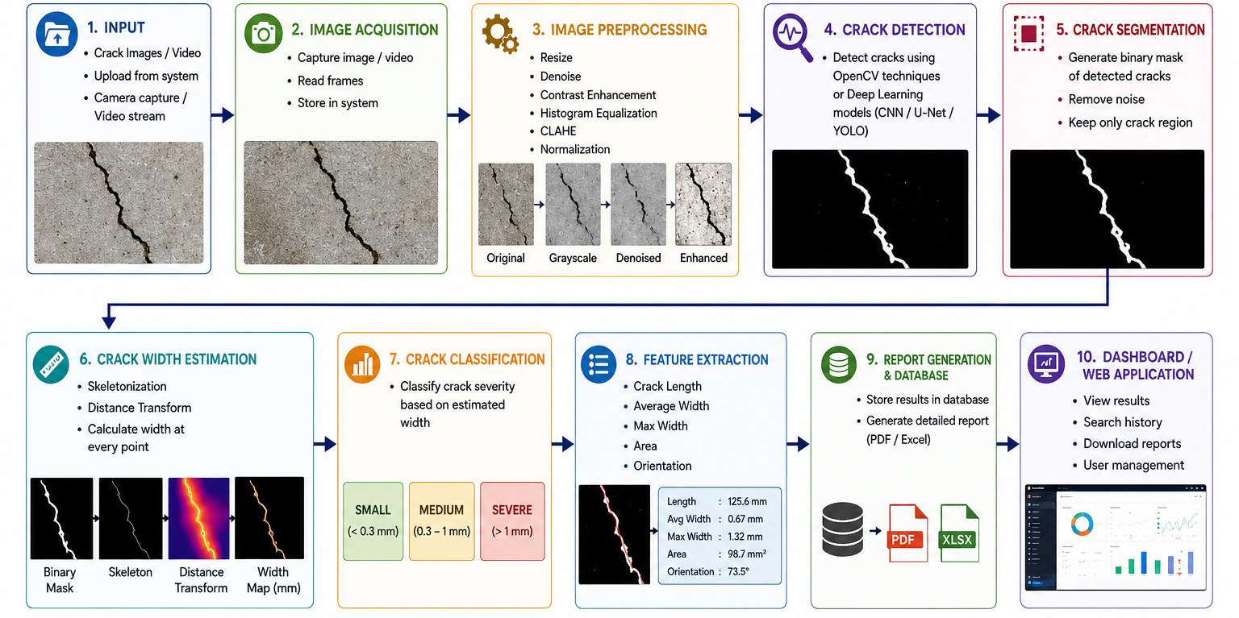

4. Tasks Accomplished
- Conducted an extensive literature review on crack detection and width estimation techniques using computer vision.
- Analyzed project requirements and finalized the project objectives and scope.
- Selected the technology stack, including Python, OpenCV, NumPy, and Matplotlib, for system development.
- Designed the overall system architecture and processing workflow for automated crack identification.
- Collected and organized sample crack images for dataset preparation and testing.
- Implemented image preprocessing techniques such as grayscale conversion, image resizing, Gaussian filtering, and thresholding.
- Developed the crack detection module using OpenCV image processing algorithms, including edge detection and contour extraction.
- Designed the crack width estimation approach based on pixel measurements and image calibration.
- Implemented crack severity classification based on the estimated crack width.
- Performed initial testing of the detection pipeline and verified the accuracy of crack identification using sample images.
- Prepared the project workflow, methodology, and technical documentation for the progress report and presentation.
5. Tasks in Progress / Next Plan
- System analysis
- database design
- module planning
- development environment setup

6. Learnings / Skills Acquired
- Gained practical knowledge of Computer Vision and Digital Image Processing concepts.
- Learned to use the OpenCV library for image preprocessing, edge detection, contour detection, and crack segmentation.
- Improved programming skills in Python by implementing image processing algorithms.
- Acquired experience with NumPy and Matplotlib for image manipulation, numerical computation, and result visualization.
- Learned techniques for crack width estimation using pixel-based measurements and image calibration.
- Understood the design and implementation of a complete computer vision workflow, from image acquisition to crack severity classification.
- Developed problem-solving and debugging skills while testing and improving the crack detection pipeline.
- Enhanced knowledge of research methodology, technical documentation, and project presentation.
- Improved teamwork, time management, and project planning skills during the development process.
- Gained experience in evaluating system performance and interpreting experimental results for real-world structural inspection applications.
References
- Bradski, G., & Kaehler, A. (2008). Learning OpenCV: Computer vision with the OpenCV library. " O'Reilly Media, Inc.".
- Pham, M. V., Ha, Y. S., & Kim, Y. T. (2023). Automatic detection and measurement of ground crack propagation using deep learning networks and an image processing technique. Measurement, 215, 112832.
- Yang, Y. S., Wu, C. L., Hsu, T. T., Yang, H. C., Lu, H. J., & Chang, C. C. (2018). Image analysis method for crack distribution and width estimation for reinforced concrete structures. Automation in Construction, 91, 120-132.
- Oh, J., Matsumoto, Y., & Arai, K. (2023). Development of Crack Detection and Crack Length Calculation Method using Image Processing. International Journal of Advanced Computer Science & Applications, 14(12), 330.
Evaluation (To be filled by Mentor)
Criteria | Bloom’s Level | Excellent (20) | Good (15) | Average (10) | Poor (5) | Marks Obtained (Out of 20)
Problem Definition | L4–Analyze | Clearly defined, justified real-world problem | Defined but lacks depth | Vague problem | No clear problem
Project Title Relevance | L2–Understand | Highly precise and aligned | Mostly relevant | Partially relevant | Misleading
Scope of Work | L5–Evaluate | Well-defined scope, deliverables, constraints | Defined with minor gaps | Broad/unclear | No scope
Related Study | L4–Analyze | 3–5 sources analyzed critically | Sources listed | Minimal references | No study
Clarity & Presentation | L3–Apply | Structured, professional | Minor issues | Some confusion | Poor
Total Marks

Evaluation
Student Signature | Mentor (Company)  Signature

Mentor (Institute) Remarks
________________________________________________________________________________________________________________________________________________________________________________________________________________________________________________________________________________________________________________________________________________________________________________________________________________________________________________________________________________________________________________________________________________________________________________________________________________________________________________________________________________________________________________________________________________________________________________________________________________________________________________________________________________________________________________________________________________________________________________________________________________________________________________________________________________________________________________________________________________________________________________________________________________________________________________________________________________________________________________________________________________________________________

